**Business Problem**

In recent years, City Hotel and Resort Hotel have seen high cancellation rates. Each hotel is now dealing with a number of issues. As a result, including fewer revenues and less than ideal hotel room use. Consequently, *lower the cancellation rates* is the primary goal in both hotels in order to increase their efficiency in generating revenue. And for us to offer thorough business advice to address this problem.

The analysis of hotel booking cancellations as well as other factors that have no bearing on their business and yearly revenue generation are the main topic of this report.

**Assumptions**

1. No unusual occurrence between year- and year- will have a substantial impact on the data used.
2. The all information is updated. And it can be used to analyze a hotel’s possible plans in an efficient manner.
3. There is no unanticipated negatives to the hotel employing and advised technique.
4. The hotels are not currently using any suggested solutions.
5. The biggest factor affecting the effectiveness of generating revenue is – cancellation of reservations.
6. One cancellation results in vacant room for that day or certain period of time.
7. Clients make cancellations in the same year the book.

**Research Questions**

We are researching on those affecting variables of the effectiveness for this given dataset.

1. What are the main variables that enhance the reservations cancellations?
2. How can we reduce the cancellation rate?
3. What are the variables on which pricing and promotional decisions should be made.

**Hypothesis**

1. When price difference is so much than each other, more cancellations occur on that much expensive hotel.
2. Longer waiting list may occur the high cancellations.
3. Customers from online travel agencies make much cancelation of reservations.
4. In some specific countries may the reservation cancelation occur much .
5. Assigned room type is below standard than clients assumed.
6. Refundable type clients have much cancelation.
7. Transient type customers make more cancelation.

**Analysis and Findings**

From this below card, we can notice that the number of cancellations is great according to the total number of customers.

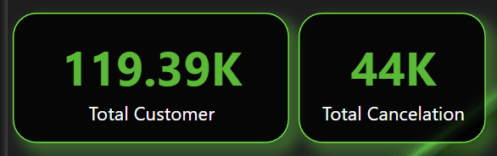

1. Visualization of cancelation and not-cancelation count

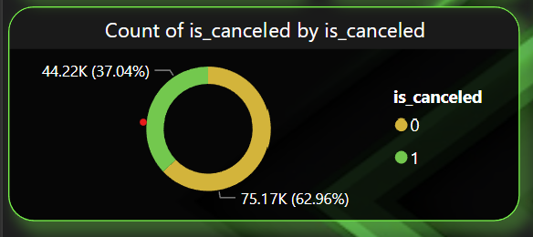

The accompanying pie chart shows the percentage of reservations those are cancelled and those that are not. It can be noticed that a significant number of reservations are not cancelled. But still the red dotted 37% reservations are cancelled, which is a great percentage; and has the significant impact of hotel’s revenue.

1. Visualization of cancelation Ratio of each Resort Hotel and City Hotel

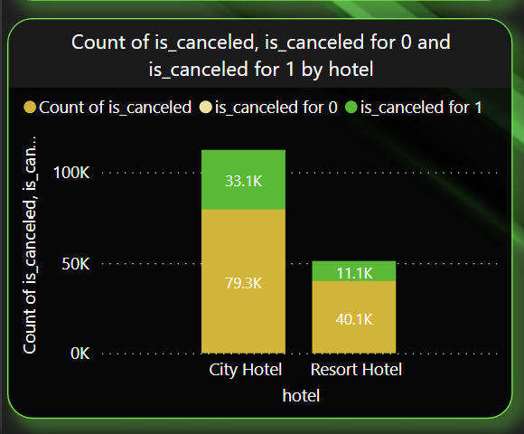

In comparison to both Hotels, the bar graph shows that City Hotel has more bookings, but it has also more reservation cancellations. So, it proves that customer first make reservations in City Hotel and then they shift to another hotel. Price can be the most affecting variable here.

1. Visualization that shows the counts of reservations and cancellations in every month

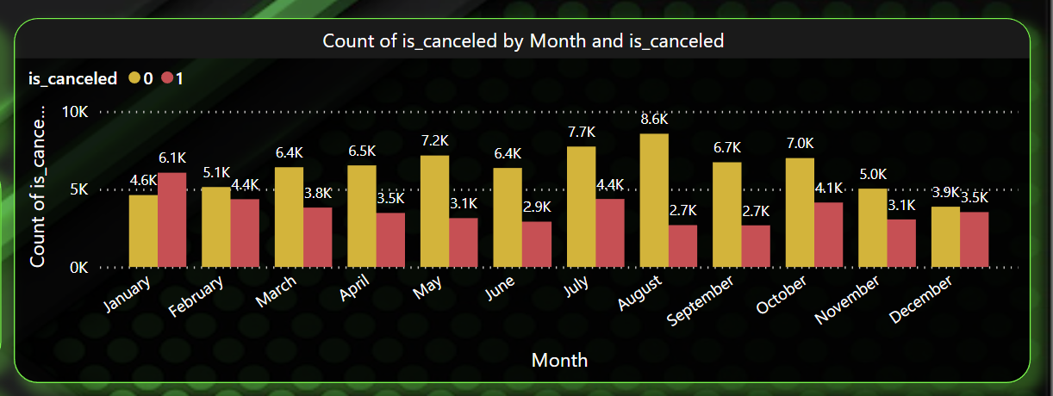

This accompanying graph shows that, in August customers make much reservations and cancellation is low. And in January cancellation is higher than reservations of each hotels.

1. Visualization of Total average daily rate ratio of every month for each hotels

As the previous bar chart showing that January has the highest number of cancelations. So in this ribbon chart we are generating the total average daily rate according to both hotels. Here we can see that in January, the difference of adr of both hotels is high. The expense of City Hotel in January is much more higher than Resort Hotel. And it is :

Resort Hotel expense in January (Total) : 0.2 million

City Hotel expense in January (Total) : 0.7 million

The difference is so high and around 0.5 million.

So, this is the main reason customers cancel reservations much in January.

Whereas, in August the difference is low. So cancellations is low accordingly.

Resort Hotel expense in August (Total) : 0.7 million

City Hotel expense in August (Total) : 0.8 million

The difference is so low and around 0.1 million.

So, each hotel can generate much more revenue than other months of the year.

We’ll see some more variables that are also responsible for reservations cancellations. And these will be our secondary variables after Pricing.

1. Visualizations that shows which meal is affecting factor for reservation cancellations

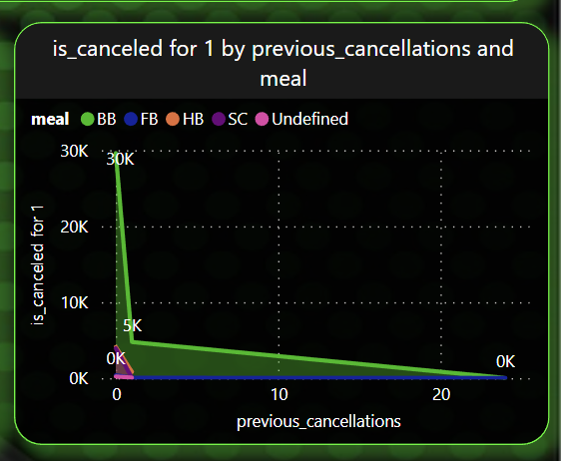

In this accompanying area chart, we’ve seen that, the meal : BB has noticeable number of cancellations. And here, those customers make much reservations cancellations who had never have cancellations history before. So they make reservations first; but when they come to the hotel, they notice the meal : BB and cancels reservations.

1. Visualization of relationships between waiting list and cancellations

In City hotel has much cancellations. After expense, one of the secondary factor for impacting revenue generation is this waiting list. We can see that City Hotel’s maximum waiting days is 391, which is so much. Customers make reservations and when they get a long waiting days, they just cancels reservations.

1. Visualization showing how marketing agent is related to reservations cancellations

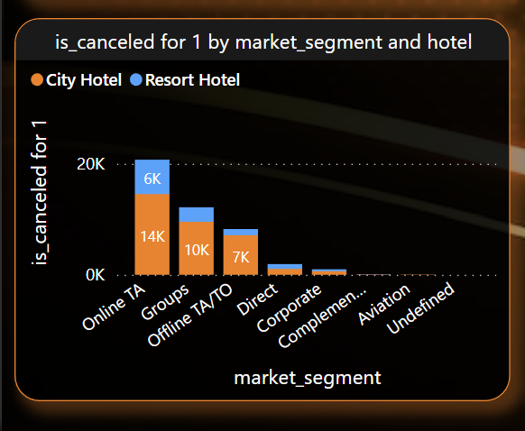 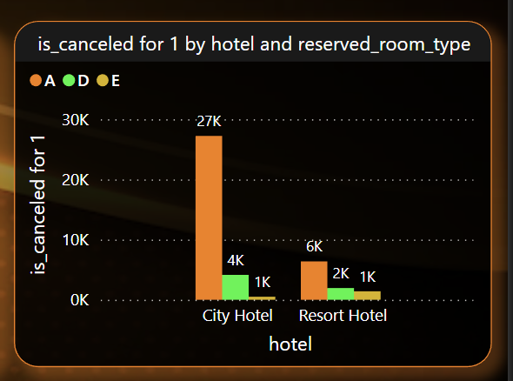

In these two accompanying graph, we can see that, those customers who come from Online Travel Agencies, they make more booking cancellations. Because In the photos of the hotels they provides in their online websites or social media pages; are so attractive, but actually not so. So the clients first book the room type : A grade seeing those attractive photos; but when they come to confirm hotel booking, they cancels reservations.

1. Visualizations how country is affecting factor

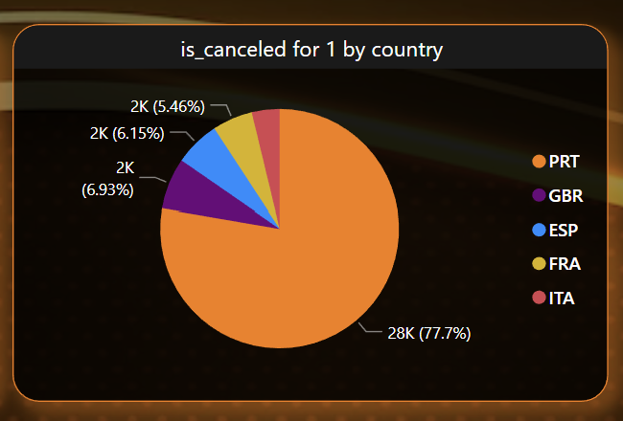

Following the above chart, the country - Portugal has the greatest portion of reservation cancellations rate and it is around 78% for it’s price.

1. Visualization showing the type of customer make much cancellations of reservations

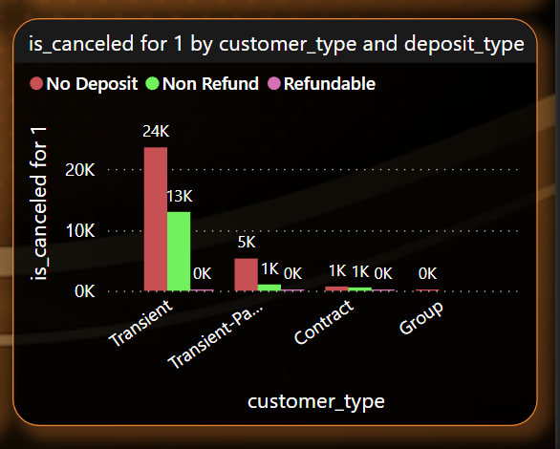

We can notice from the above stacked bar chart that, Transient type of customers who have no deposit history, they make more cancellations than others. And the number is around 24K.

**Suggesions**

1. *Primary and Main :* 
   1. Cancellations rises as the price does. In order to prevent cancellation of reservations, Hotels could work with Expense strategies. They can make the prices reasonable considering their locations.
   2. As the price of City Hotel is more than Resort Hotel, and mainly in Portugal; hotel authorities can make discount for the customers at weekend and holidays. Additionally, they can take promotional strategies in Portugal.
   3. In January Hotels can start campaigns and marketing and provide clients with adjustable amount of costing.
2. *Secondary :*

After taking upper actions, Hotels can work on other revenue generating affecting variables.

* 1. The meal : BB can be improved.
  2. The waiting list days can be reduced.
  3. Hotels can work on- the online travel agencies can provide actual photos of facilities, the hotels actually have.
  4. Transient type of customers can be taken under a certain amount of advanced payment.

**Interactive and Dinamic Hotel Booking Dashboard**

***First Page :***

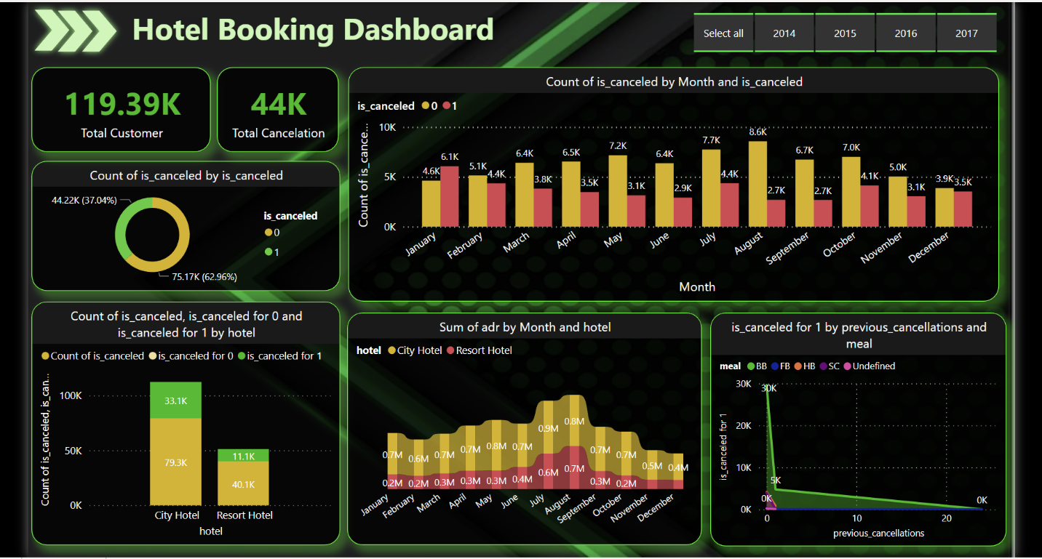

***Second Page :***

